

# Task 5 – Pass Submission

Student Number: 103181157   
Student Name: Nguyen Nam Tung

### Pass 5a

Paste your screen capture(s) for this task here.

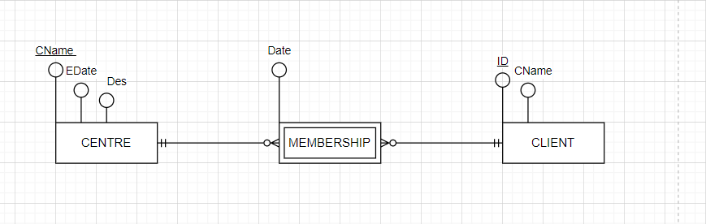

### Pass 5b

Paste your screen capture(s) for this task here.

CENTRE (CName, Edate, Des)

PK (Cname)

CLIENT(ID, CName)

PK (ID)

MEMBERSHIP (CName, ID, Date)

PK (CName, ID)

FK (CName) REFERENCES CENTRE

FK (ID) REFERENCES CLIENT

### Pass 5c

Paste your screen capture(s) for this task here.

DROP TABLE CENTRE;

DROP TABLE CLIENT;

DROP TABLE MEMBERSHIP;

CREATE TABLE CLIENT (

ID NUMBER,

CNAME VARCHAR (100),

PRIMARY KEY (ID)

);

CREATE TABLE CENTRE (

CNAME VARCHAR (100),

EDATE DATE,

DES VARCHAR (100),

PRIMARY KEY (SNAME)

);

CREATE TABLE MEMBERSHIP (

DATE DATE,

ID INT,

CNAME VARCHAR(100),

PRIMARY KEY (ID, Cname),

FOREIGN KEY (ID) REFERENCES CLIENT

FOREIGN KEY (CNAME) REFERENCES CENTRE

);

### Pass 5d

Paste your screen capture(s) for this task here.

Normalisation: a database design technique used to create relational schema. It is often used as an alternative to ERDs, and it requires no diagram. It aims to achieve third Normal Form 3NF.

### Pass 5e

Paste your screen capture(s) for this task here.

|  |  |  |  |  |  |  |
| --- | --- | --- | --- | --- | --- | --- |
| CustID | Name | Phone | CarRego | MakeModel | StartDate | ReturnDate |
| 125 | John Coles | 0401112233 | 1AU8HK | Mazda 3 | 31/08/2020 | 7/09/2020 |
| 125 | John Coles | 0401112233 | 1LM3AB | Hyundai i30 | 14/11/2020 | 21/11/2020 |
| 278 | Erin Trump | 0466121455 | 1AU8HK | Mazda 3 | 12/09/2020 | 19/09/2020 |
| 278 | Erin Trump | 0466121455 | 1KA2CA | Toyota | 1/10/2020 | 8/10/2020 |
| 278 | Erin Trump | 0466121455 | 1CZ8JK | Camry | 10/11/2020 | 12/11/2020 |
| 278 | Erin Trump | 0466121455 | 1AU8HK | Mazda 3 | 26/11/2020 | 1/12/2020 |
| 721 | Emma Knox | 0423544117 | 1LM3AB | Hyundai i30 | 10/09/2020 | 13/09/2020 |